**MODULE: 5 (Database)**

1. **What do you understand By Database?**

Database is an organized collection of structured data, usually stored in computer and easy to find, access, update and manipulate.

**2.**  **What is Normalization?**

Normalization is the process of structuring data within a database to minimize redundancy and eliminate undesirable characteristics.

**3.**  **What is Difference between DBMS and RDBMS?**

|  |  |
| --- | --- |
| **DBMS** | **RDBMS** |
| [DBMS](https://www.geeksforgeeks.org/introduction-of-dbms-database-management-system-set-1/) stores data as file. | [RDBMS](https://www.geeksforgeeks.org/rdbms-architecture/) stores data in tabular form. |
| Data elements need to access individually. | Multiple data elements can be accessed at the same time. |
| No relationship between data. | Data is stored in the form of tables which are related to each other. |
| DBMS does not support distributed databases. | RDBMS supports distributed databases. |
| It stores data in either a navigational or hierarchical form. | It uses a tabular structure where the headers are the column names, and the rows contain corresponding values. |
| It deals with small quantity of data. | It deals with large amount of data. |
| Data redundancy is common in this model. | Keys and indexes do not allow Data redundancy. |
| It is used for small organization and deal with small data. | It is used to handle large amounts of data. |
| It supports single user. | It supports multiple users. |
| Data fetching is slower for the large amount of data. | Data fetching is fast because of relational approach. |
| The data in a DBMS is subject to low security levels with regards to data manipulation. | There exists multiple levels of data security in a RDBMS. |
| Examples: [XML](https://www.geeksforgeeks.org/xml-basics/), Window Registry, Forxpro, dbaseIIIplus etc. | Examples: [MySQL](https://www.geeksforgeeks.org/architecture-of-mysql/), [PostgreSQL](https://www.geeksforgeeks.org/what-is-postgresql-introduction/), [SQL](https://www.geeksforgeeks.org/what-is-sql/) Server, Oracle, Microsoft Access etc. |

**4.**  **What is MF Cod Rule of RDBMS Systems?**

### **1: The Information Rule**

All information, whether it is user information or metadata, that is stored in a database must be entered as a value in a cell of a table. It is said that everything within the database is organized in a table layout.

### **2: The Guaranteed Access Rule**

Each data element is guaranteed to be accessible logically with a combination of the table name, primary key (row value), and attribute name (column value).

### **3: Systematic Treatment of NULL Values**

Every Null value in a database must be given a systematic and uniform treatment.

**4: Active Online Catalog Rule**

The database catalog, which contains metadata about the database, must be stored and accessed using the same relational database management system.

### **5: The Comprehensive Data Sublanguage Rule**

A crucial component of any efficient database system is its ability to offer an easily understandable data manipulation language ([DML](https://www.geeksforgeeks.org/dml-full-form/)) that facilitates defining, querying, and modifying information within the database.

### **6: The View Updating Rule**

All views that are theoretically updatable must also be updatable by the system.

### **7: High-level Insert, Update, and Delete**

A successful database system must possess the feature of facilitating high-level insertions, updates, and deletions that can grant users the ability to conduct these operations with ease through a single query.

### **8: Physical Data Independence**

Application programs and activities should remain unaffected when changes are made to the physical storage structures or methods.

### **9: Logical Data Independence**

Application programs and activities should remain unaffected when changes are made to the logical structure of the data, such as adding or modifying tables.

### **10: Integrity Independence**

Integrity constraints should be specified separately from application programs and stored in the catalog. They should be automatically enforced by the database system.

### **11: Distribution Independence**

The distribution of data across multiple locations should be invisible to users, and the database system should handle the distribution transparently.

### **12: Non-Subversion Rule**

If the interface of the system is providing access to low-level records, then the interface must not be able to damage the system and bypass security and integrity constraints.

**5.**  **What do you understand By Data Redundancy?**

Data redundancy means keeping data in two or more locations within a database or storage infrastructure.

**6.**  **What is DDL Interpreter?**

DDL is short name of Data Definition Language, which deals with database schemas and descriptions, of how the data should reside in the database.

CREATE,ALTER,DROP, TRUNCATE, RENAME & COMMENT operation are performed in DML

**7.**  **What is DML Compiler in SQL?**

DML is short name of Data Manipulation Language which deals with data manipulation, and includes common SQL statements like SELECT, INSERT, UPDATE, DELETE etc, and it is used to store, modify, retrieve, delete and update data in database.

**8.** **What is SQL Key Constraints writing an Example of SQL Key Constraints.**

There are many types of constrains

**1. PRIMARY KEY constraint**- A combination of a NOT NULL and UNIQUE. Uniquely identifies each row in a table

**2. FOREIGN KEY constraint**- Prevents actions that would destroy links between tables

**3. NOT NULL constraint** - values cannot be null

**4.UNIQUE constraint**- values cannot match any older value

**5. CHECK constraint**- Ensures that the values in a column satisfies a specific condition

**6.DEFAULT constraint**- Sets a default value for a column if no value is specified

**9.**  **What is save Point? How to create a save Point write a Query?**

A savepoint in SQL is a command used in Transaction Control Language (TCL). It allows you to mark a specific point within a transaction, which can be rolled back to without affecting the entire transaction. Essentially, savepoints act as bookmarks that help you manage transactions more flexibly

**10.** **What is trigger and how to create a Trigger in SQL?**

A trigger is a stored procedure in database which automatically invokes whenever the special event in the database occurs.

For example, a trigger can be invoked when a row is interested into a specified table.

**Types of TRIGGERS**

1. DML TRIGGER

2. DDL TRIGGER

3. LOGON TRIGGER

**Types of Triggers –**   
 We can define 6 types of triggers for each table:

**AFTER INSERT** activated after data is inserted into the table.

**AFTER UPDATE:** activated after data in the table is modified.

**AFTER DELETE:** activated after data is deleted/removed from the table.

**BEFORE INSERT:** activated before data is inserted into the table.

**BEFORE UPDATE:** activated before data in the table is modified.

**BEFORE DELETE:** activated before data is deleted/removed from the table.

CREATE Trigger [trigger-name]

CREATE TRIGGER ‘AFTER INSERT ON ’employee’ FOR EACH ROW INSERT INTO

Views

(id,first_name,last_name,salary,joining_date,department)values (new .Employee_id,new.first_namenew.last_name,new.salary, new.joining_date, new.department)

**TOPIC 2**

**1.** **Create Table Name : Student and Exam**

**STUDENT TABLE**

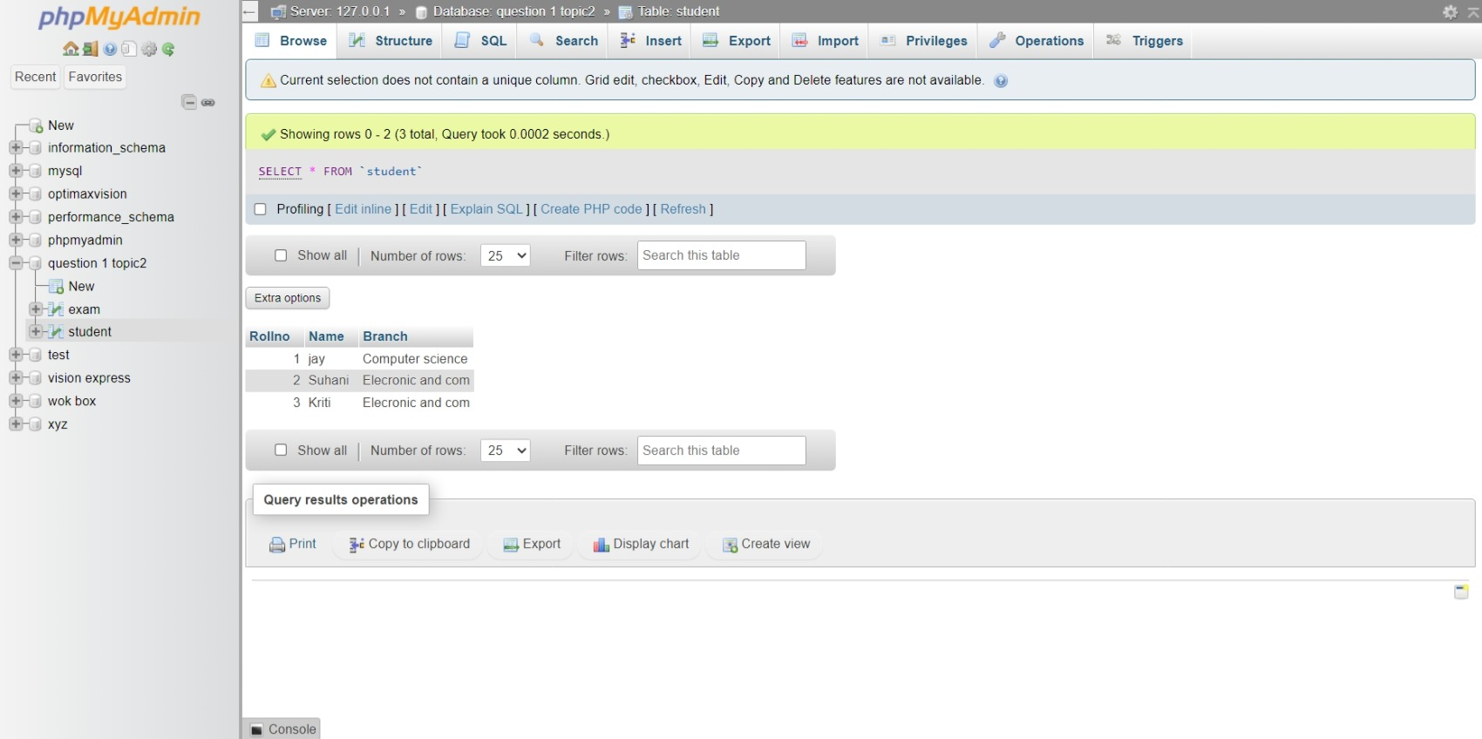**EXAM TABLE**

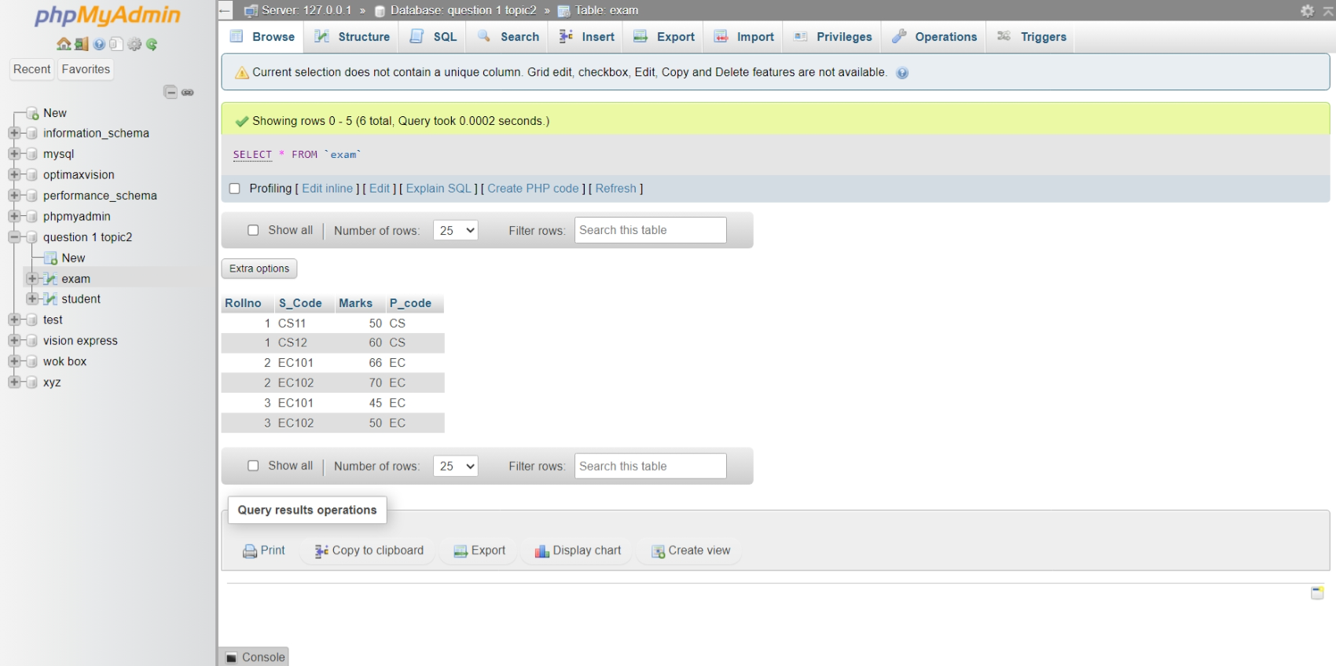

PRIMARY KEY

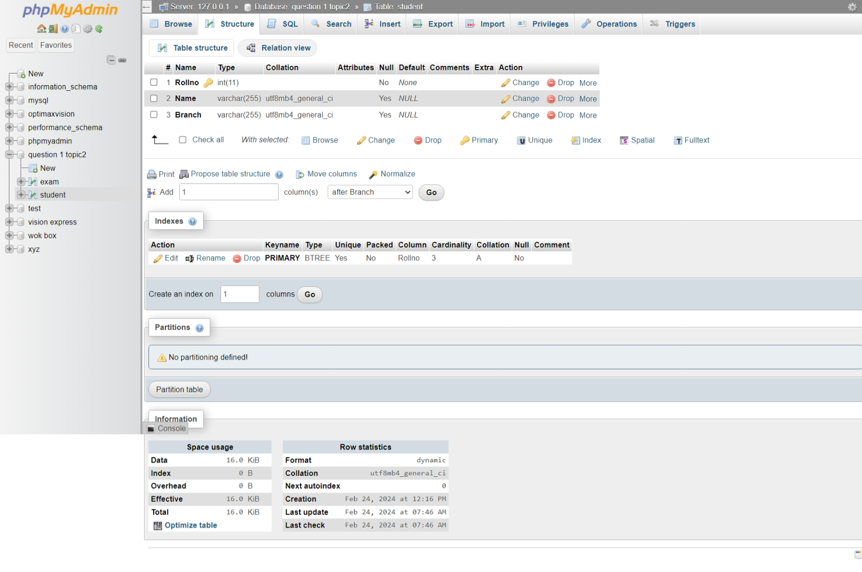

FOREIGN KEY

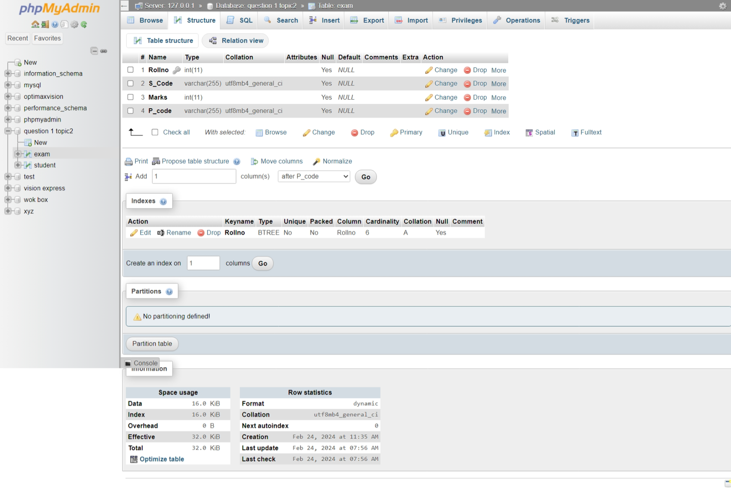

**2.** **Create table given below: Employee and Incentive Table**

EMPLOYEE TABLE

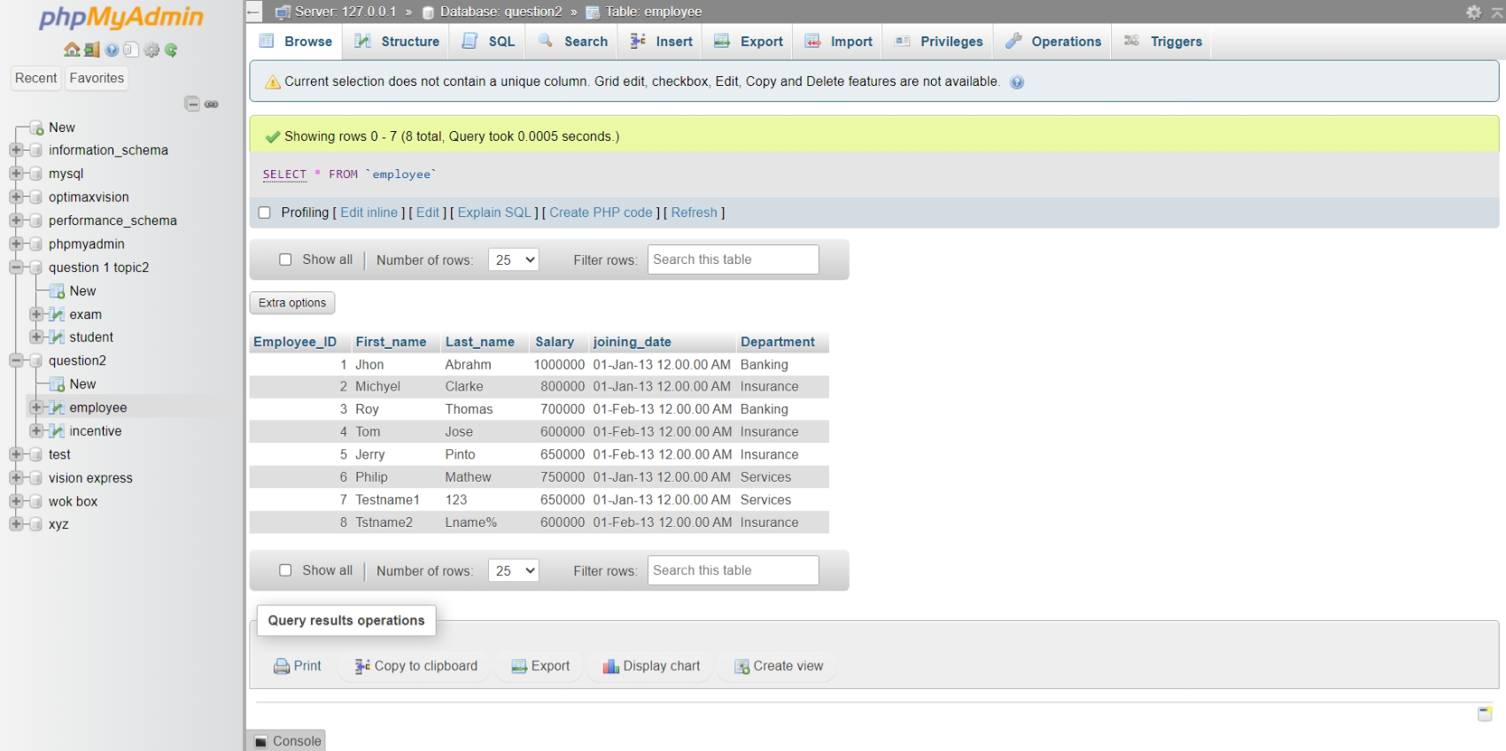

INCENTIVE TABLE

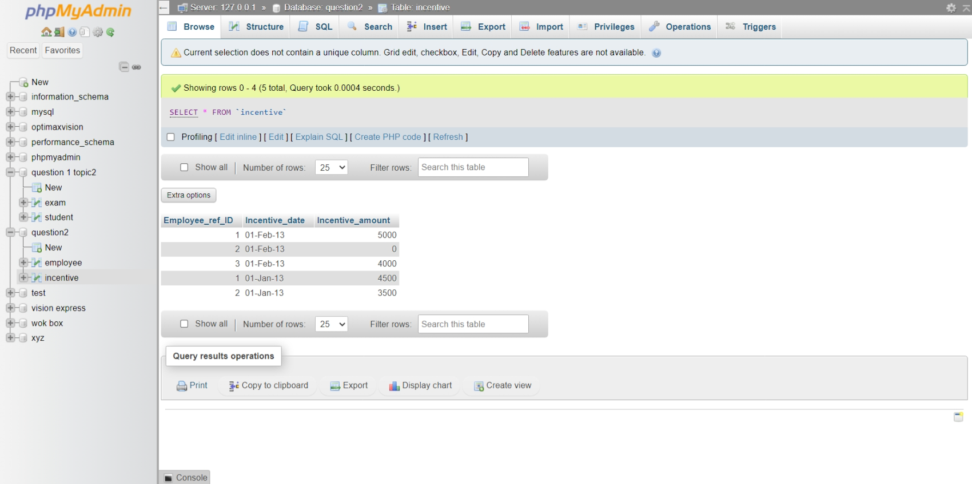

**3.** **Get First_Name from employee table using Tom name “Employee Name”.**

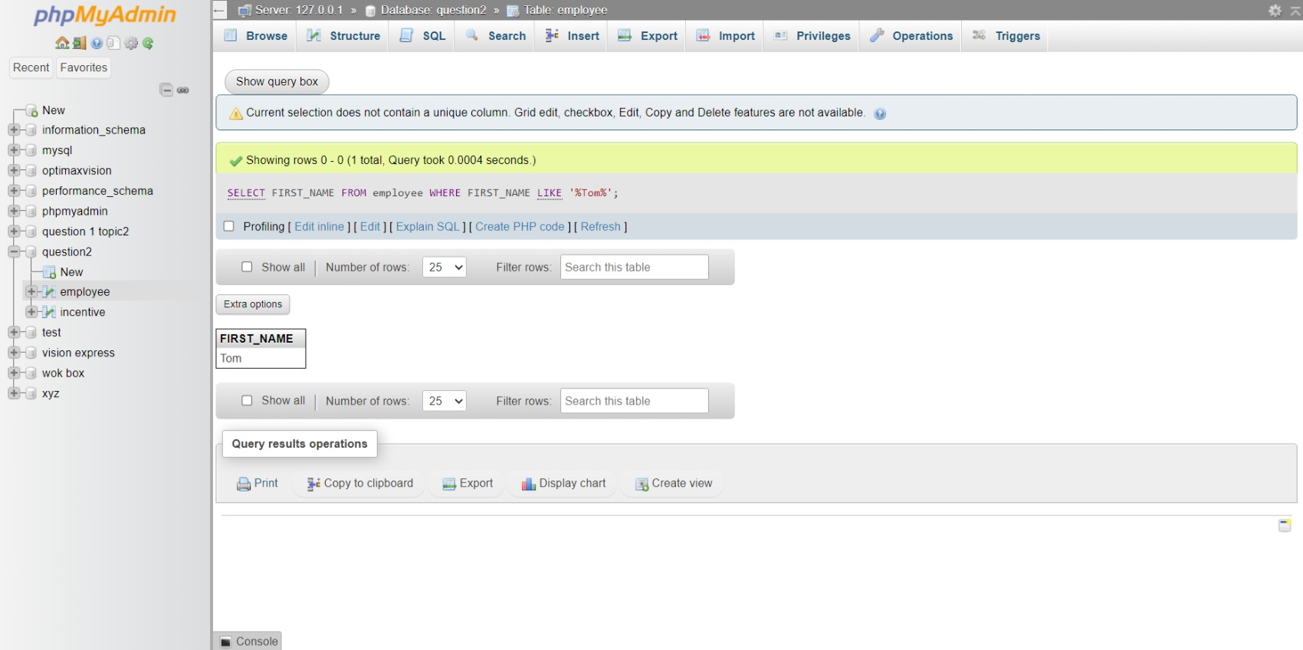

**4.** **Get FIRST_NAME, Joining Date, and Salary from employee table.**

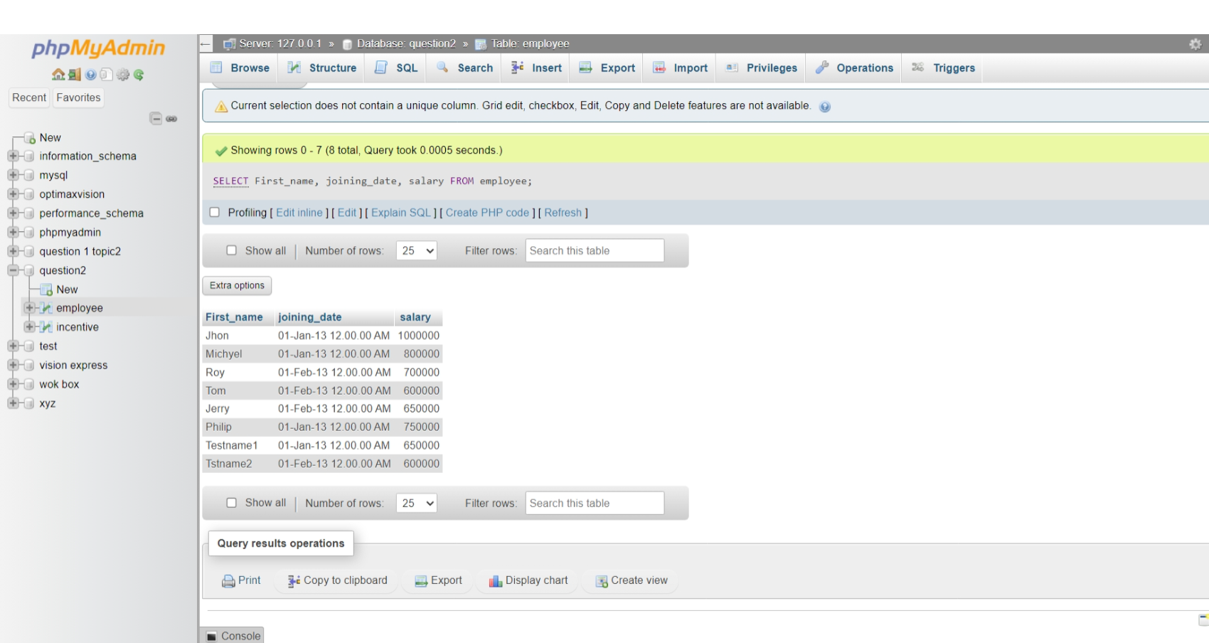

**5.**  **Get all employee details from the employee table order by First_Name**  **Ascending and Salary descending?**

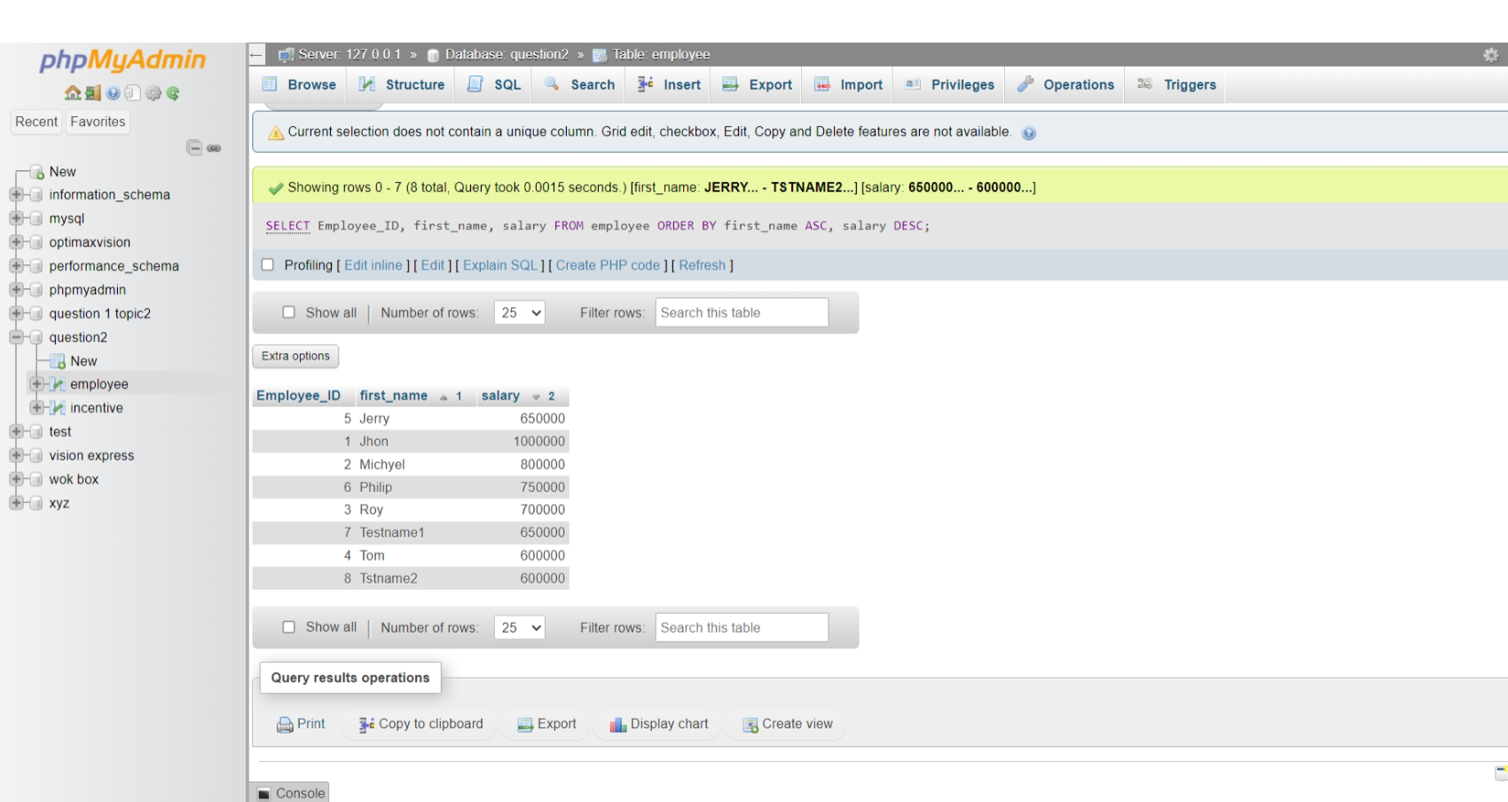

**6.**  **Get employee details from employee table whose first name contains ‘J’.**

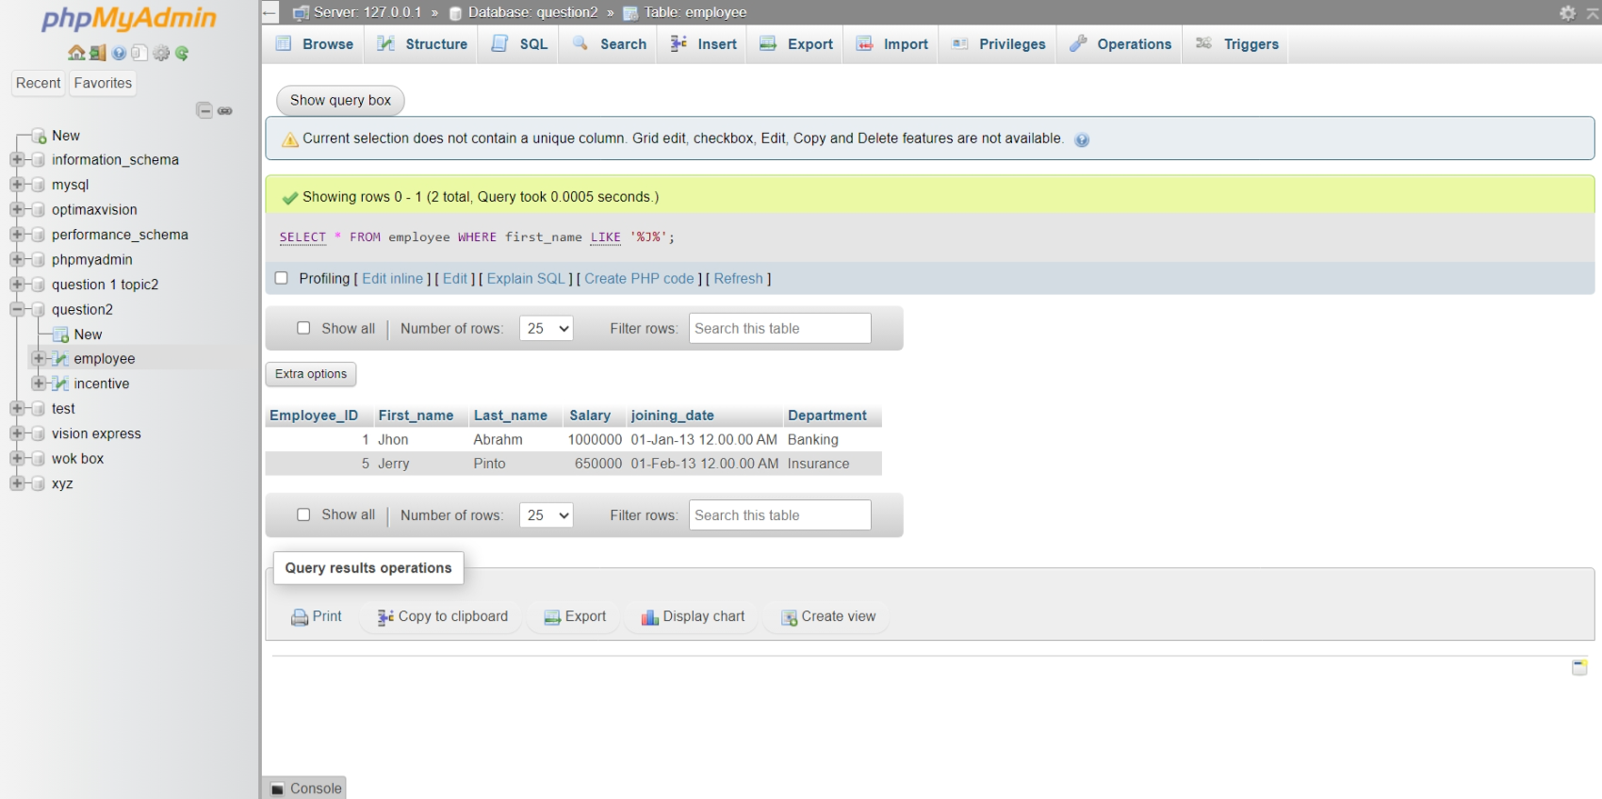

**7.**  **Get department wise maximum salary from employee table order by**

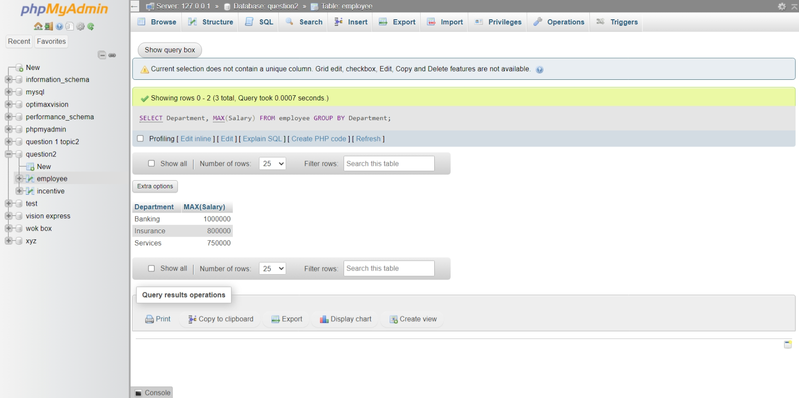

**8. salary ascending?**

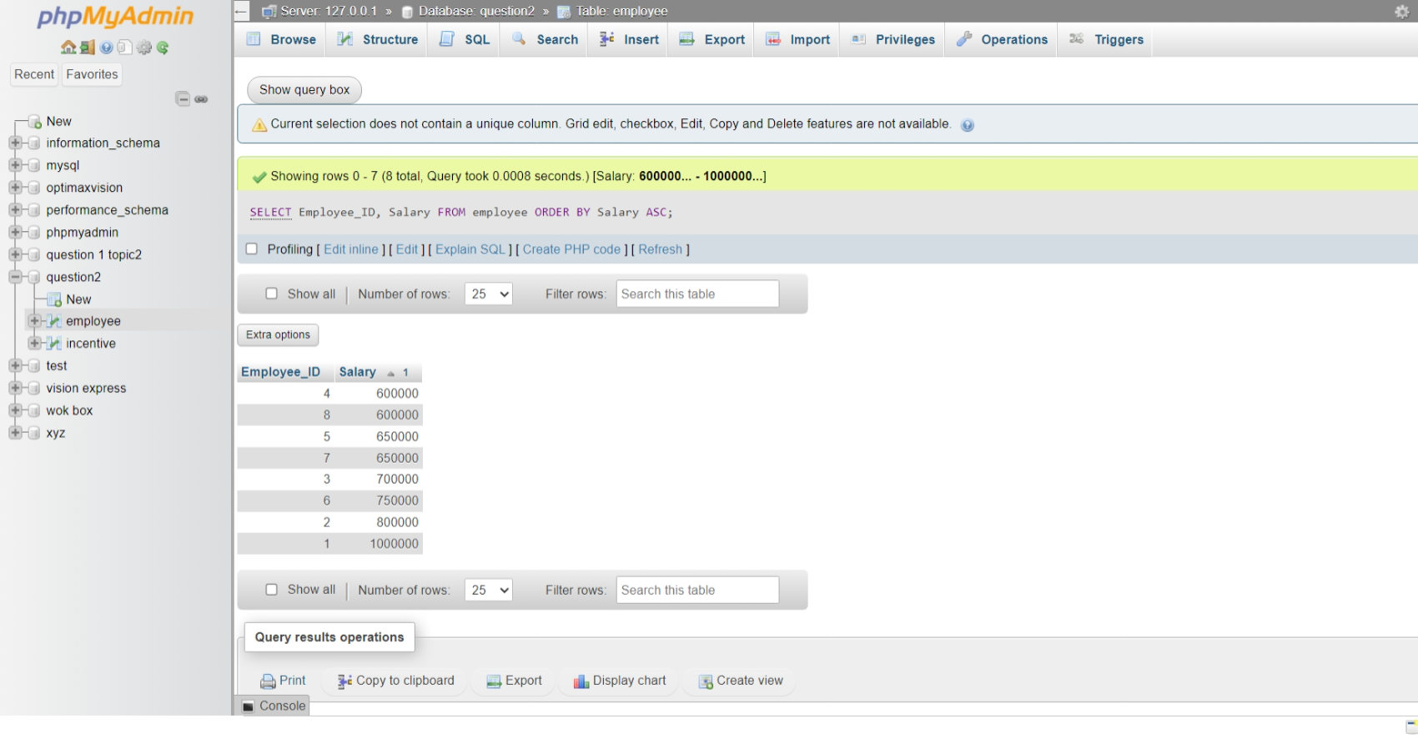**9.** **Select first name, incentive amount from employee and incentives table for**  **those employees who have incentives and incentive amount greater than300**

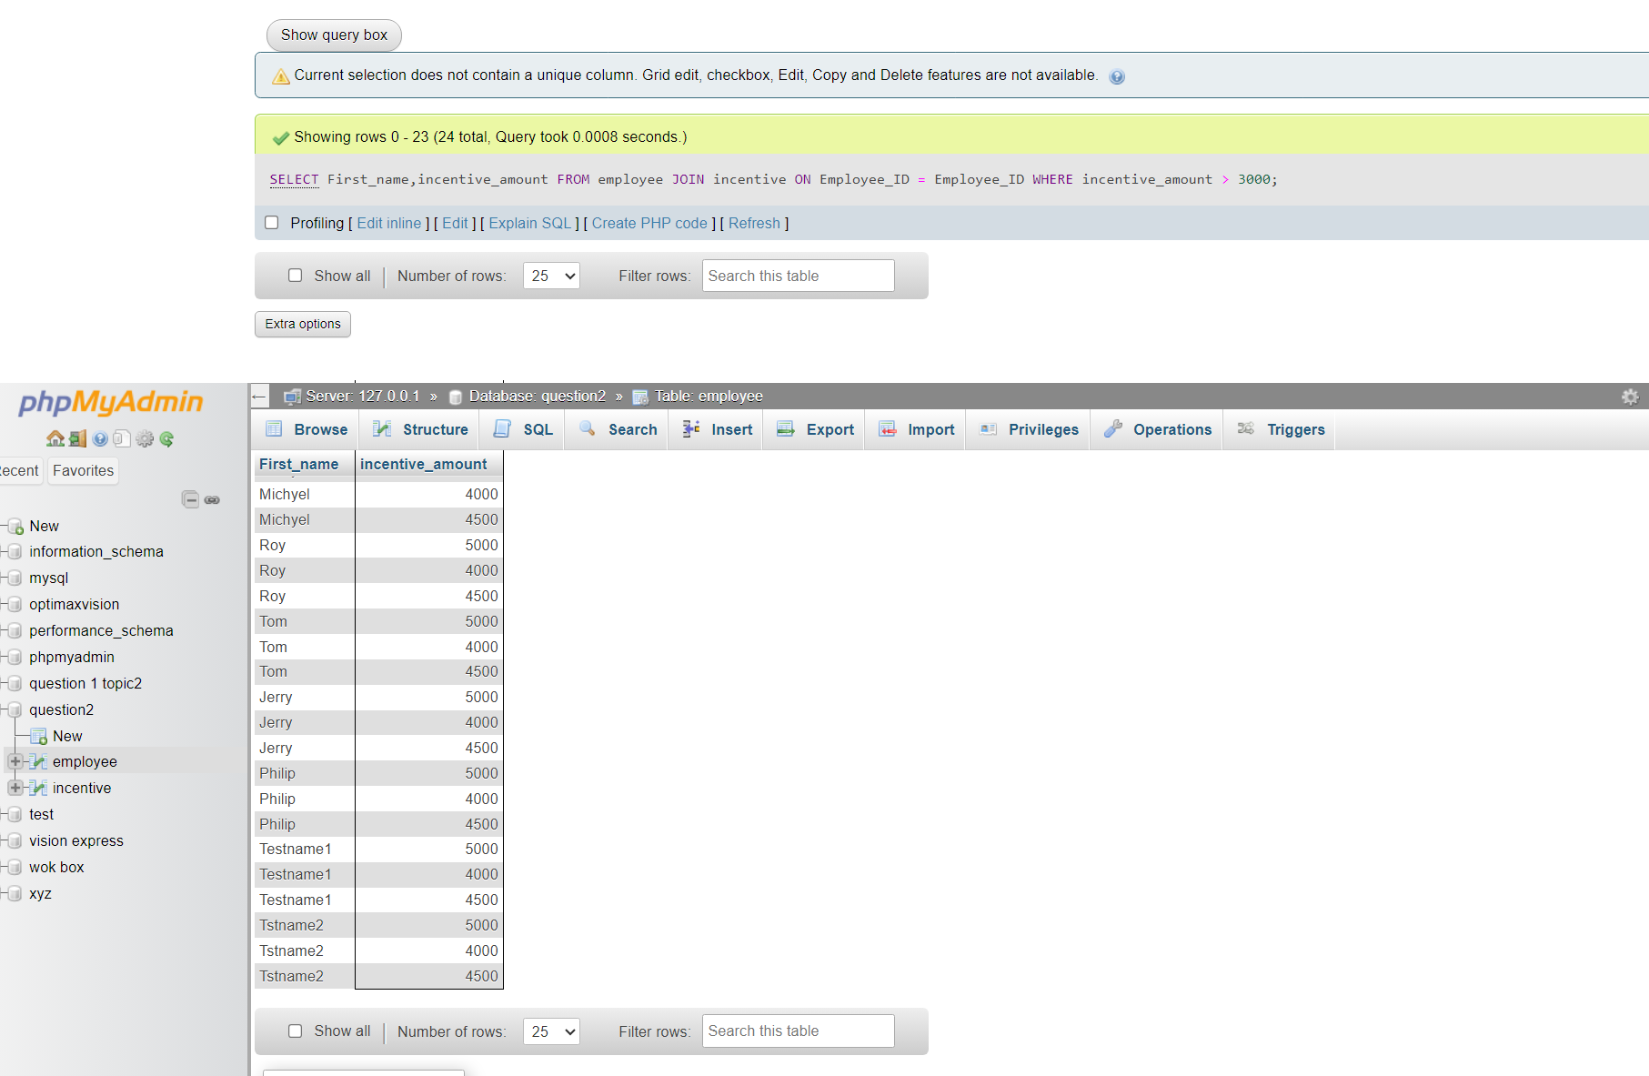

**10.**  **Create After Insert trigger on Employee table which insert records in view table**

CREATE TRIGGER AfterInsertEmployee  
ON Employee  
AFTER INSERT  
AS  
BEGIN  
 INSERT INTO View (column1, column2, column3)  
 SELECT column1, column2, column3  
 FROM INSERTED;  
END;

**11.**  **Create table given below: Salesperson and Customer**

SALESPERSON

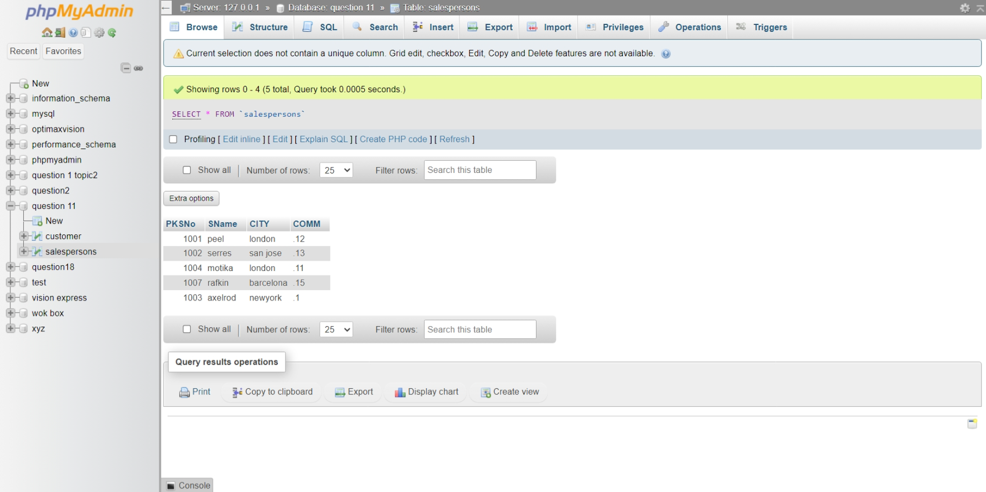

CUSTOMER

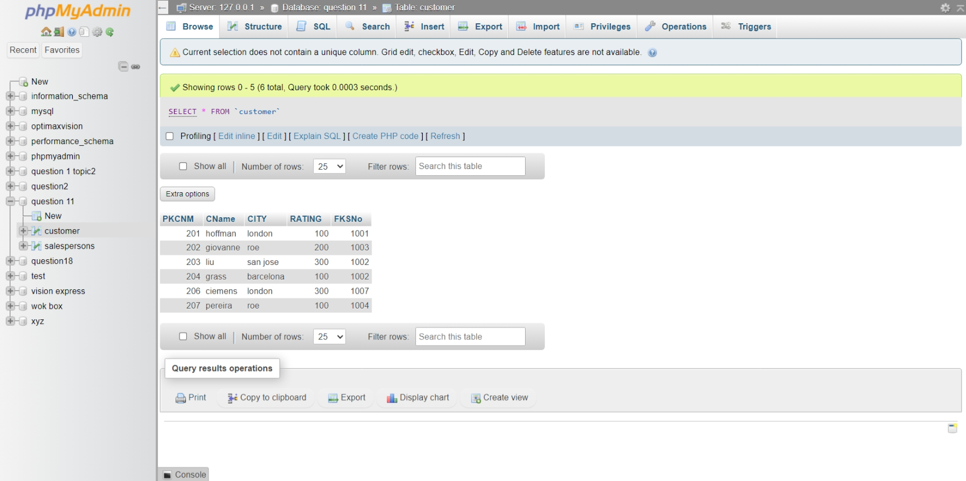

**12.** **Retrieve the below data from above table.**

You can use SELECT statement to retrieve in a specific row or retrieve data in

Specific way. We can also use this to retrieve data from one table to another table .

**13.** **All orders for more than $1000**.

SELECT customer_id,  
 SUM (order_amount) AS total_amount  
 FROM orders GROUP BY  
 customer_id HAVING  
 SUM(order_amount) > 1000;

**14.** **Names and cities of all salespeople in London with commission above 0.12.**

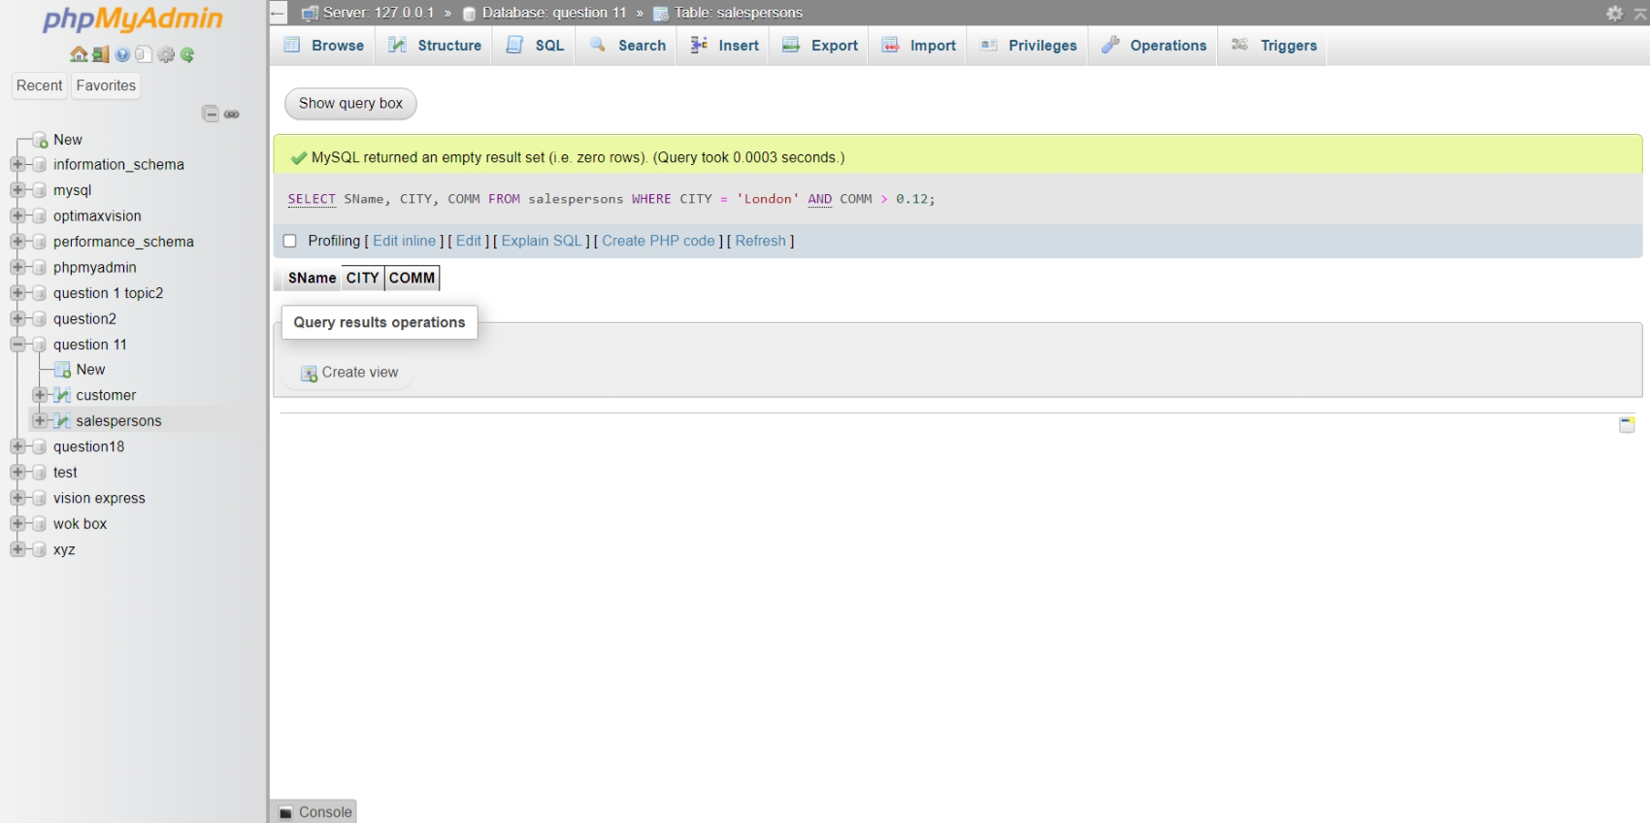**15.** **All salespeople either in Barcelona or in London**

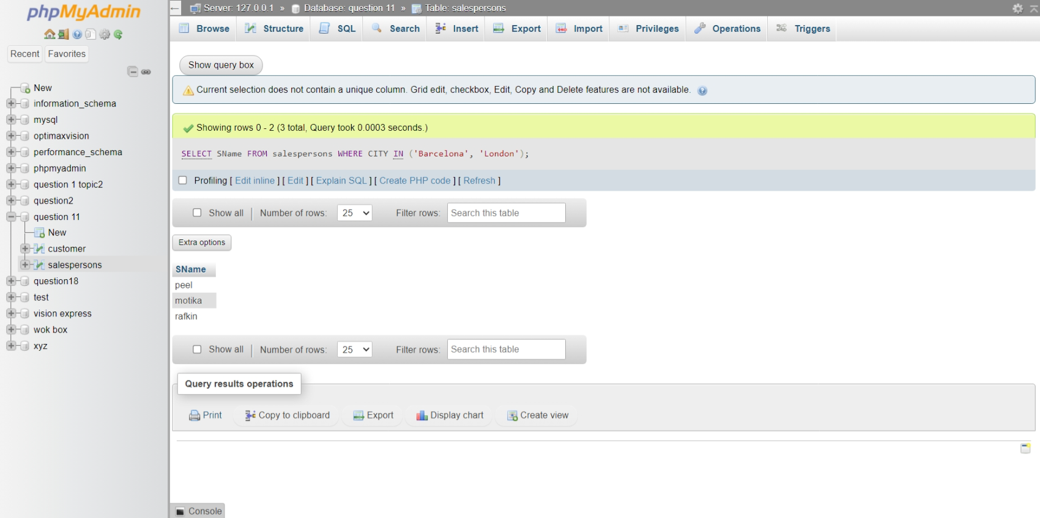

**16.** **All salespeople with commission between 0.10 and 0.12.(Boundary values**  **should be excluded)**

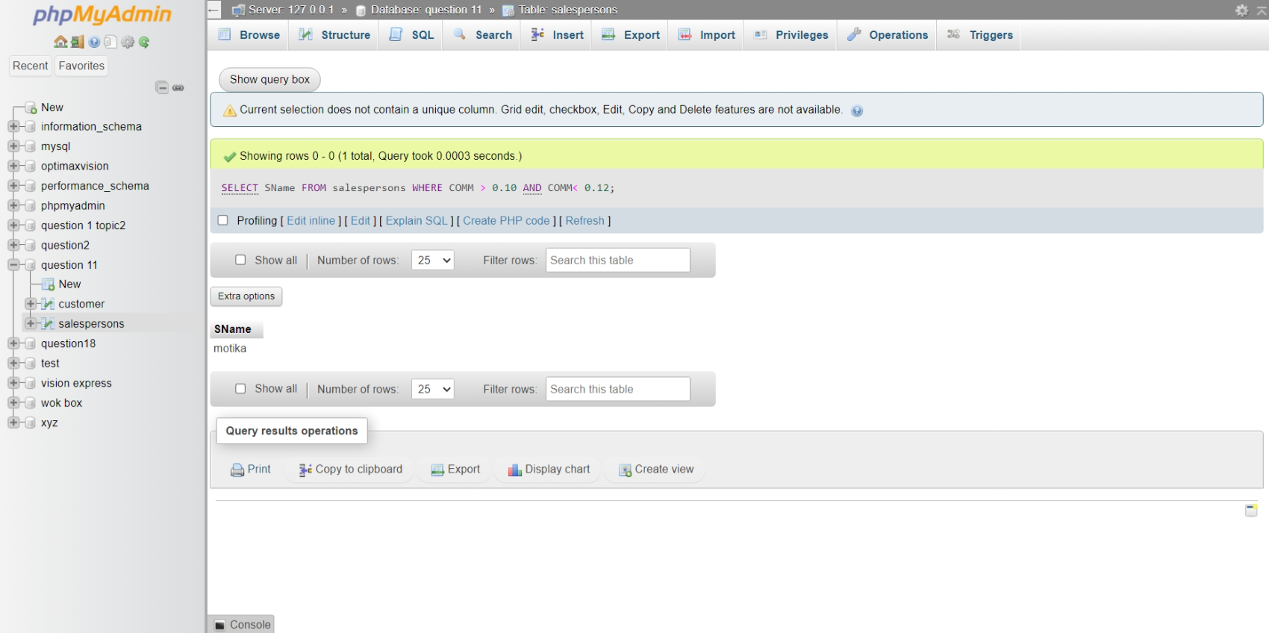

**17.** **All customers excluding those with rating <= 100 unless they are located in**  **Rome**.

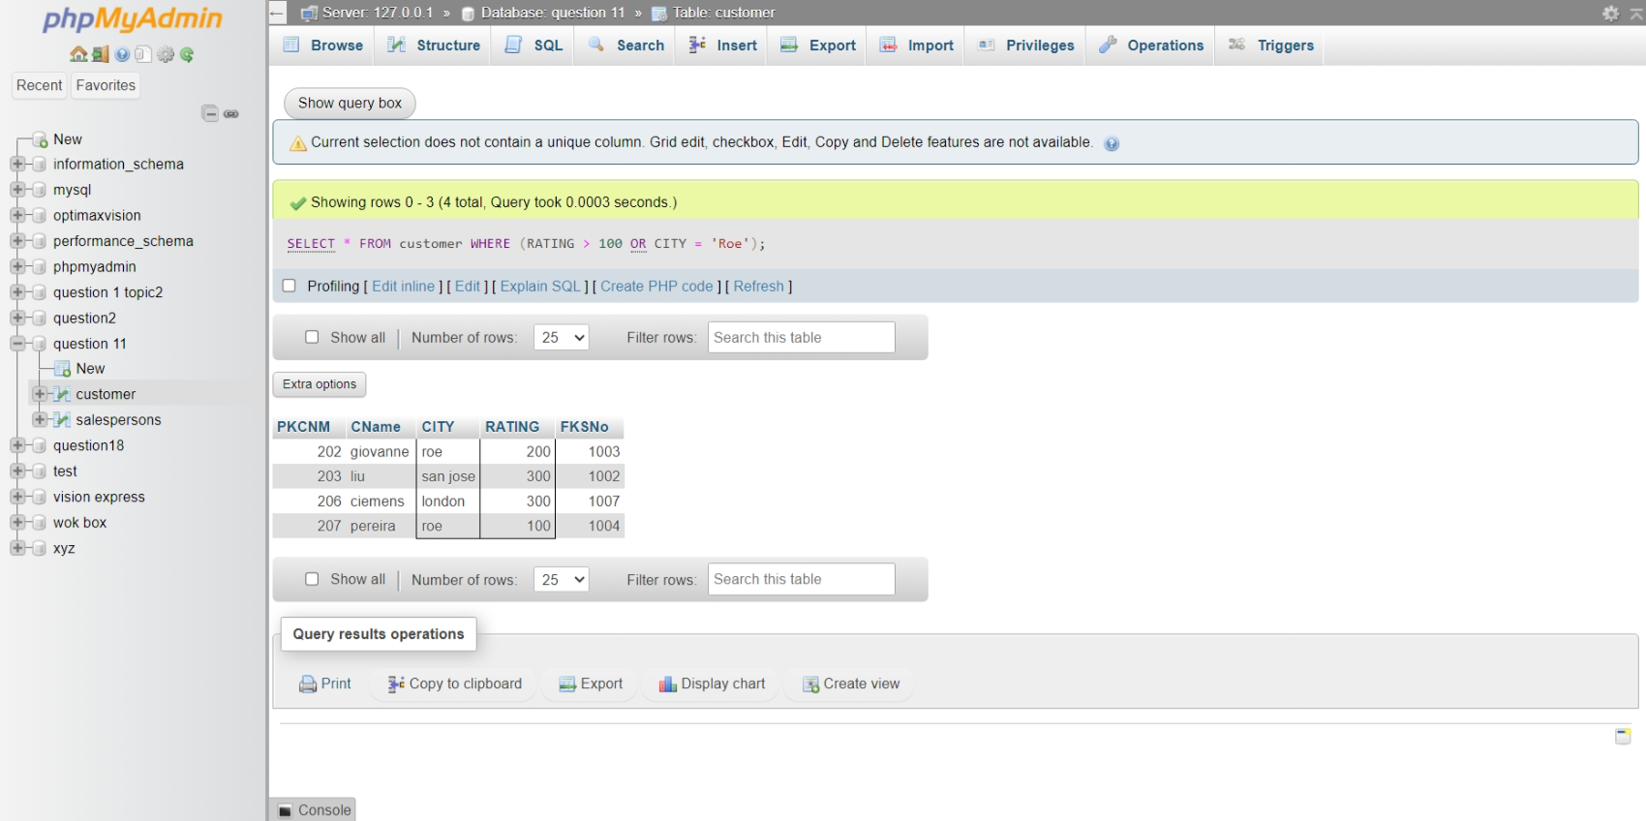

**18.** **Write a SQL statement that displays all the information about all salespeople.**

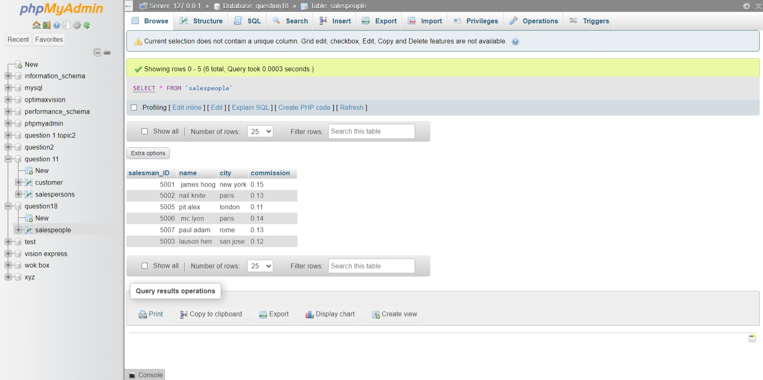

**19.** **From the following table, write a SQL query to find orders that are delivered by a**  **salesperson with ID. 5001. Return ord_no, ord_date, purch_amt.**

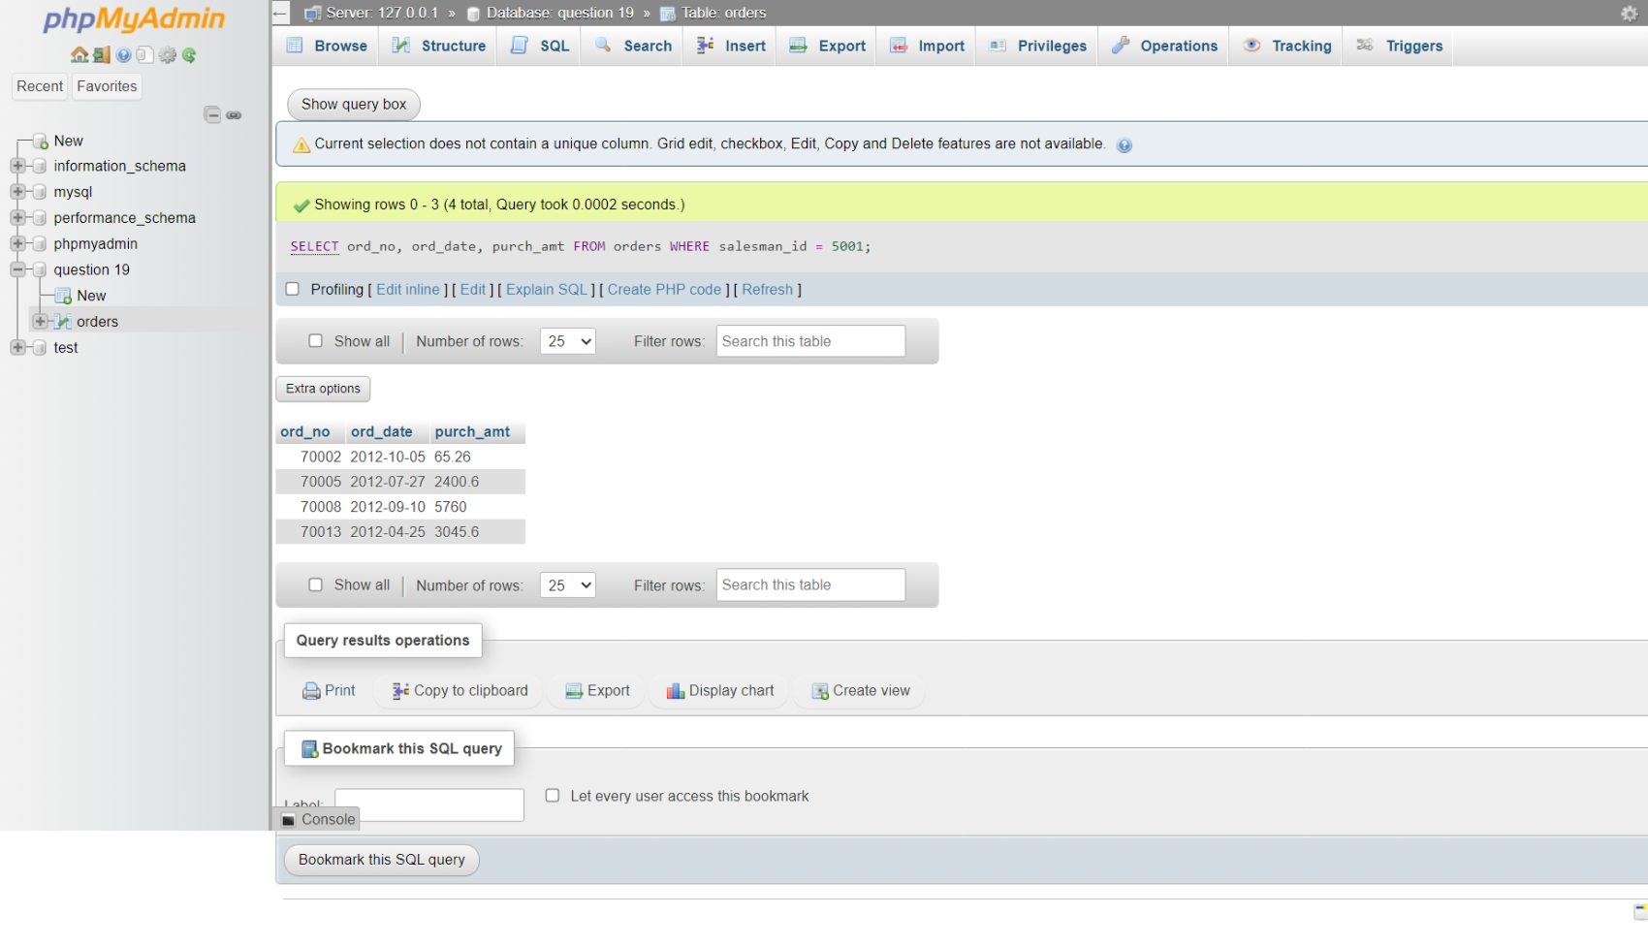

**20.** **From the following table, write a SQL query to select a range of products whose**  **price is in the range Rs.200 to Rs.600. Begin and end values are included.**  **Return pro_id, pro_name, pro_price, and pro_com**

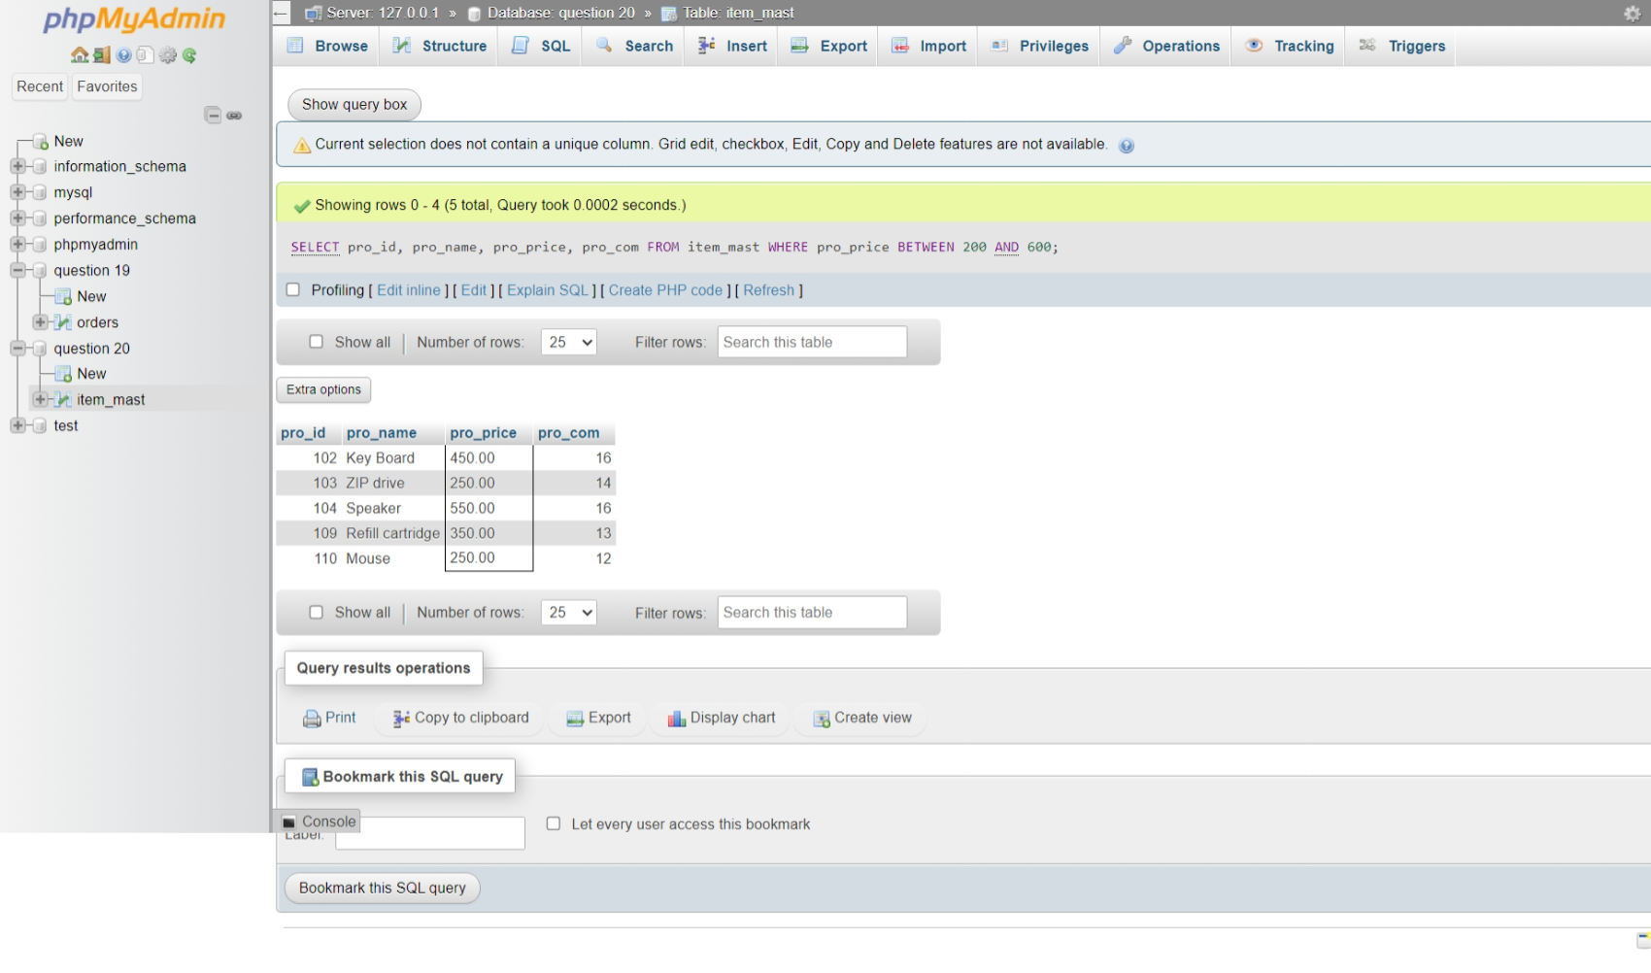**21** **From the following table, write a SQL query to calculate the averageprice for**   **a manufacturer code of 16. Return avg.**

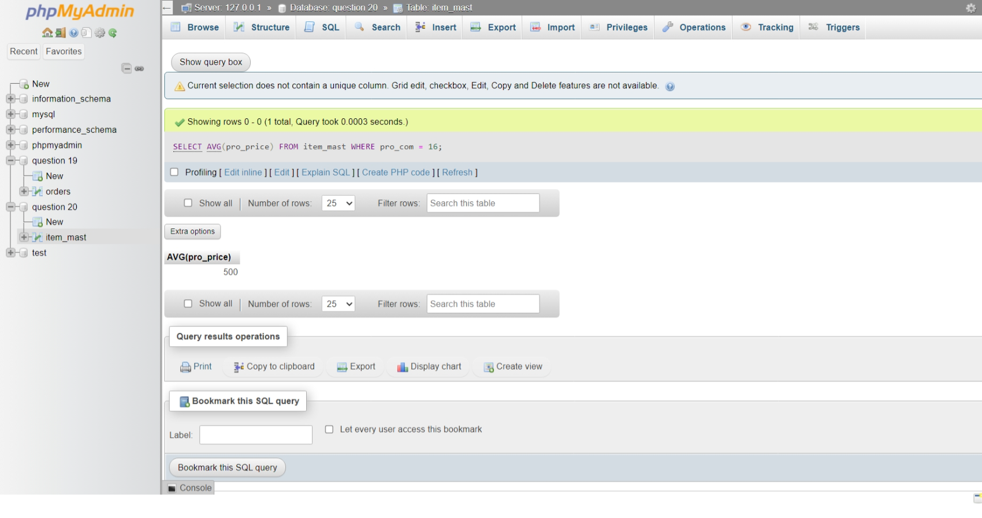

**22.** **From the following table, write a SQL query to display the pro_name as 'Item**  **Name' and pro price as 'Price in Rs.**

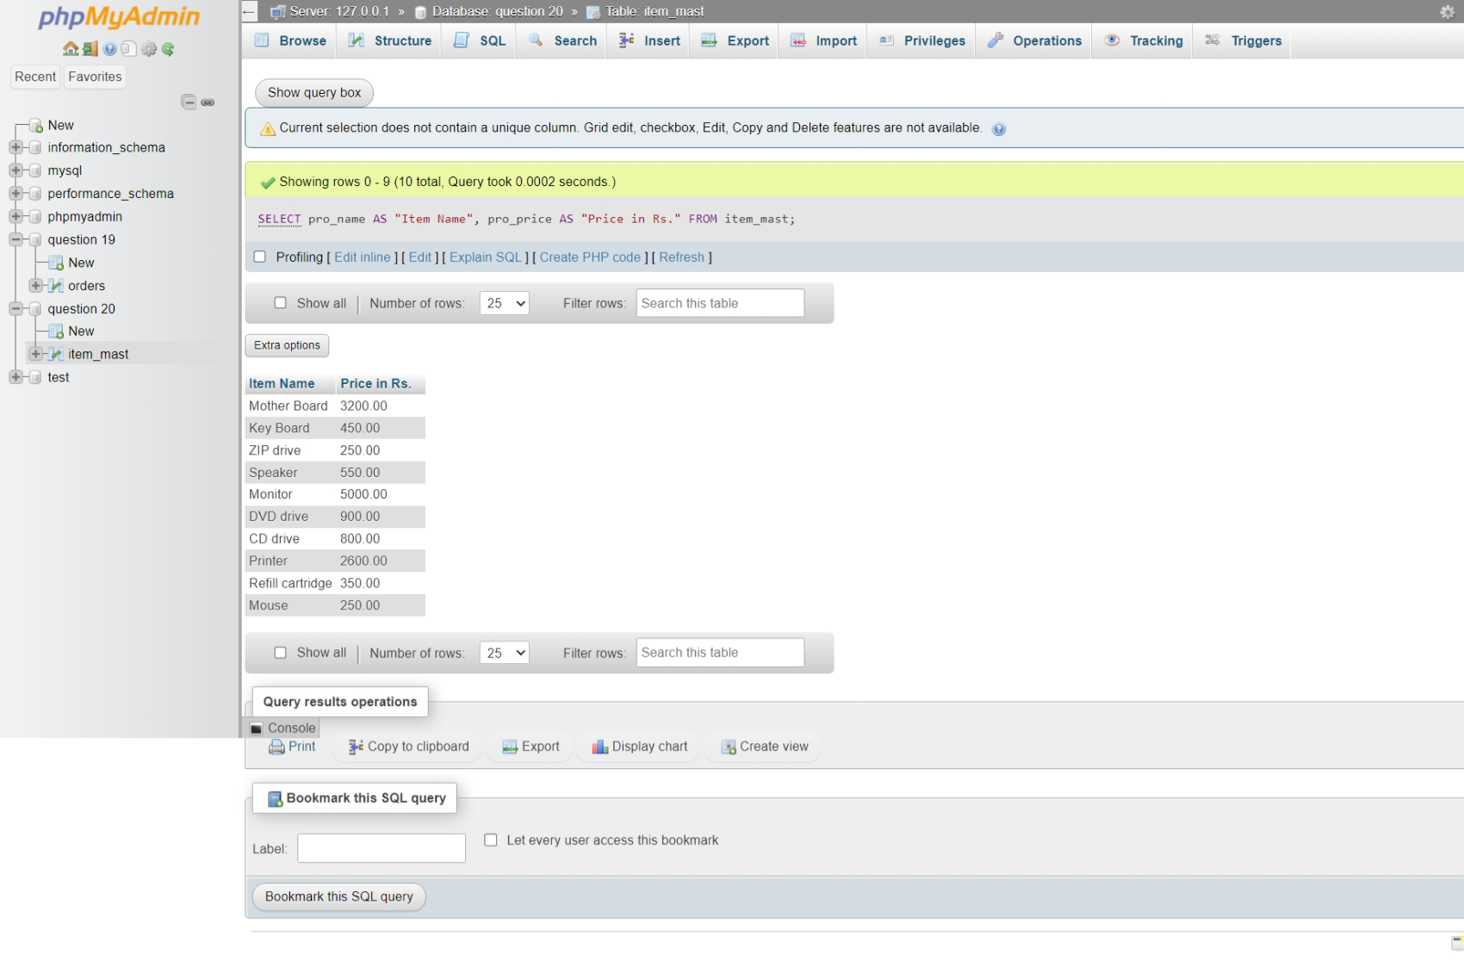

**23.** **From the following table, write a SQL query to find the items whose prices are**   **higher than or equal to $250. Order the result by product price in descending,**  **then product name in ascending. Return pro_name and pro_price.**

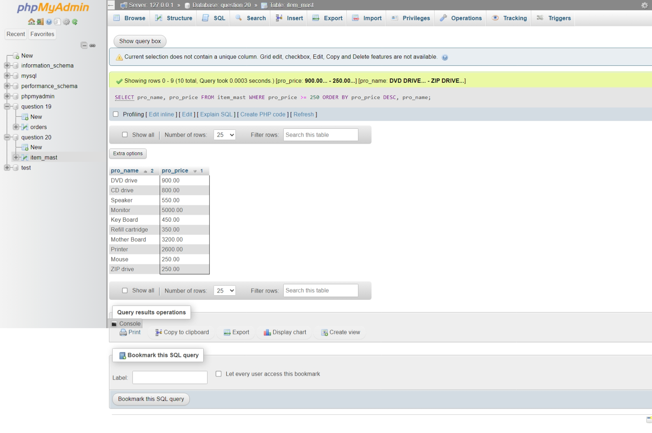

**24.** **From the following table, write a SQL query to calculate the average price of the**  **items for each company. Return average price and company code.**

